Student Name: Liu Jiahao

Student ID: 21096764D

Lab2a Report:

Exercise:

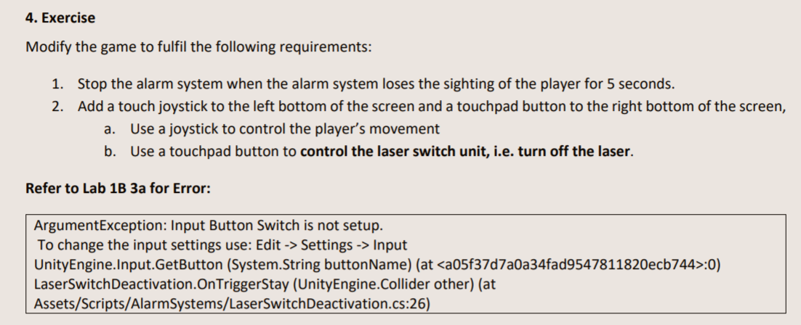

Ex1:

Use time elapse to stop alarm when lose sighting.

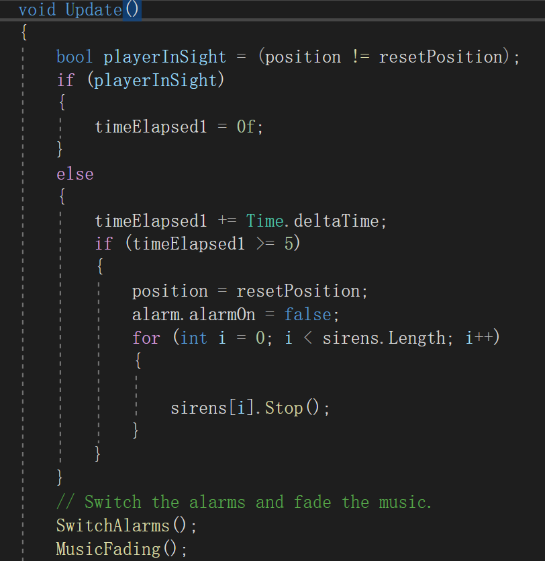

Ex2:

Add canvas:



Sphere script:

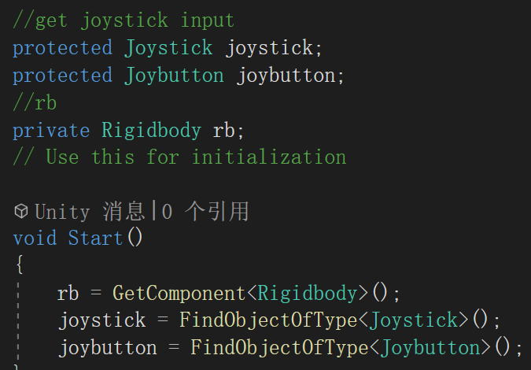

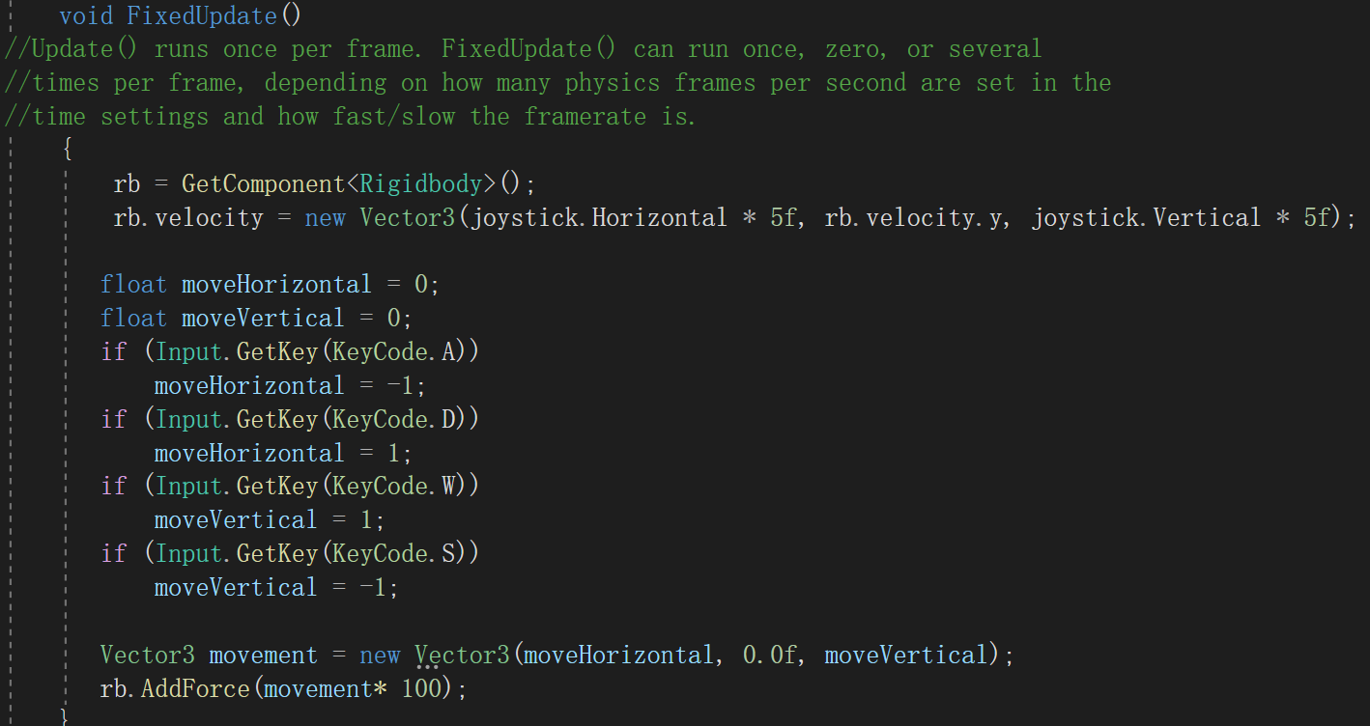

Layser switch:

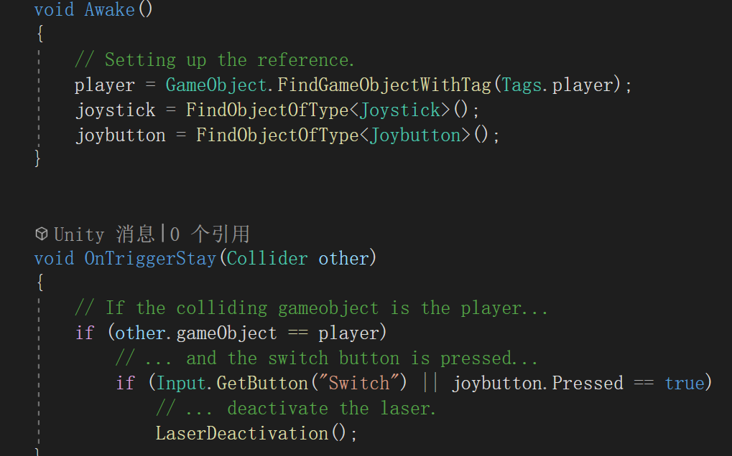

Problems met:

No problems.

Combined part:

1. Button setting

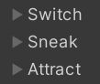

3 more buttons

1. Problem met:

The mesh-AI should set again, including set the nav-mesh surface as AI nav route.